**robot framework installation and integration with Jenkins**

**robot framework installation and integration with Jenkins** 1

ENV 3

Install Jenkins 3

install Jenkins 3

Check Jenkins service status 3

jenkins path 3

First login Jenkins UI 4

install RF and Third library 7

Install Robotframework 7

Modify HttpLibrary code 8

Running RF test cases 9

Case execution condition 9

Problems encountered 9

Create Jenkins Porject 10

Enter an item name 11

Source Code Management 11

Build Triggers 11

Build Environment 12

Build 12

Post-build Actions 12

Jenkins System Config 15

E-mail Over View 17

## ENV

|  |  |  |
| --- | --- | --- |
| Type | Version | Desc |
| OS | Ubuntu 16.04 | Need lib higher libc lib/python/apache, out storage ISO not match |
| Jenkins | 2.32.3 | Jenkins |
| RF | 3.0.2 (Python 2.7.12 on linux2) | Robot framework, used for running RF testcases |
|  |  |  |

## Install Jenkins

### install Jenkins

jenkins@jenkins:~$ wget -q -O - https://jenkins-ci.org/debian/jenkins-ci.org.key | sudo apt-key add -

OK

jenkins@jenkins:~$ sudo sh -c 'echo deb http://pkg.jenkins-ci.org/debian-stable binary/ > /etc/apt/sources.list.d/jenkins.list'

jenkins@jenkins:~$

sudo apt-get update

sudo apt-get install jenkins

### Check Jenkins service status

jenkins@jenkins:~$ sudo service jenkins status

● jenkins.service - LSB: Start Jenkins at boot time

Loaded: loaded (/etc/init.d/jenkins; bad; vendor preset: enabled)

Active: active (exited) since 五 2017-03-03 18:03:06 CST; 46s ago

Docs: man:systemd-sysv-generator(8)

3月 03 18:03:05 jenkins systemd[1]: Starting LSB: Start Jenkins at boot time...

3月 03 18:03:05 jenkins jenkins[5041]: * Starting Jenkins Continuous Integration Server jenkins

3月 03 18:03:05 jenkins su[5059]: Successful su for jenkins by root

3月 03 18:03:05 jenkins su[5059]: + ??? root:jenkins

3月 03 18:03:05 jenkins su[5059]: pam_unix(su:session): session opened for user jenkins by (uid=0)

3月 03 18:03:06 jenkins jenkins[5041]: ...done.

3月 03 18:03:06 jenkins systemd[1]: Started LSB: Start Jenkins at boot time.

### jenkins path

Access path：http://localhost:8080

Installed path：/var/lib/jenkins

Log path：/var/log/jenkins

Create a project directory in Jenkins installation directory of the jobs.

### First login Jenkins UI

###### Getting Started

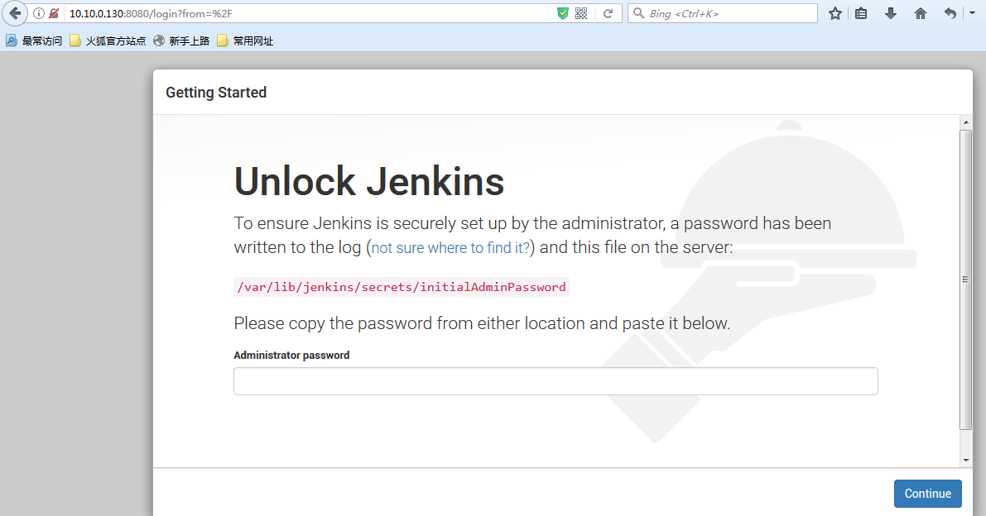

###### after input Administrator password

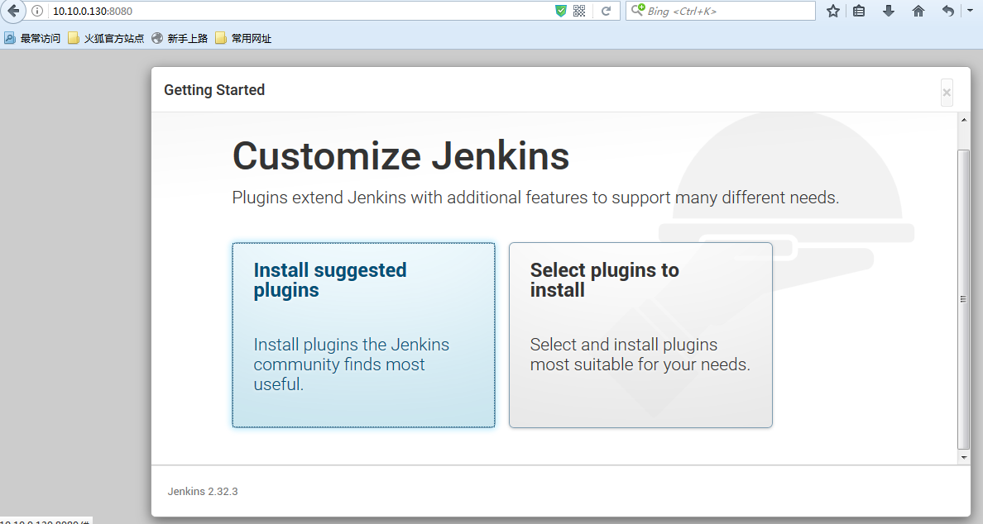

###### Select “Install suggested plugins”

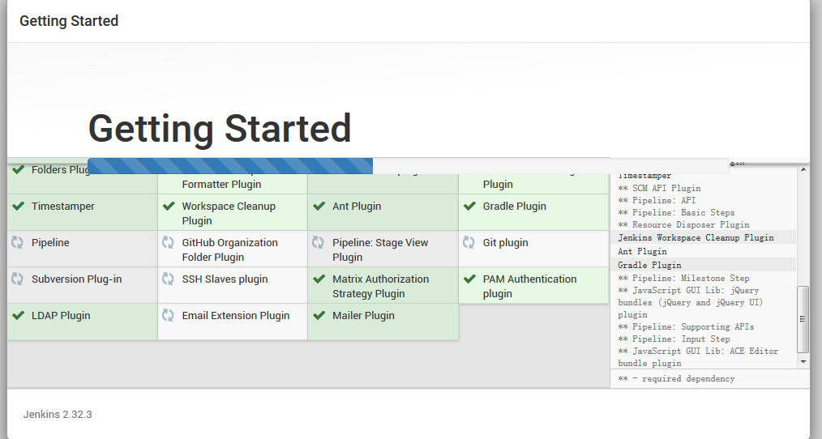

###### Create First Admin User

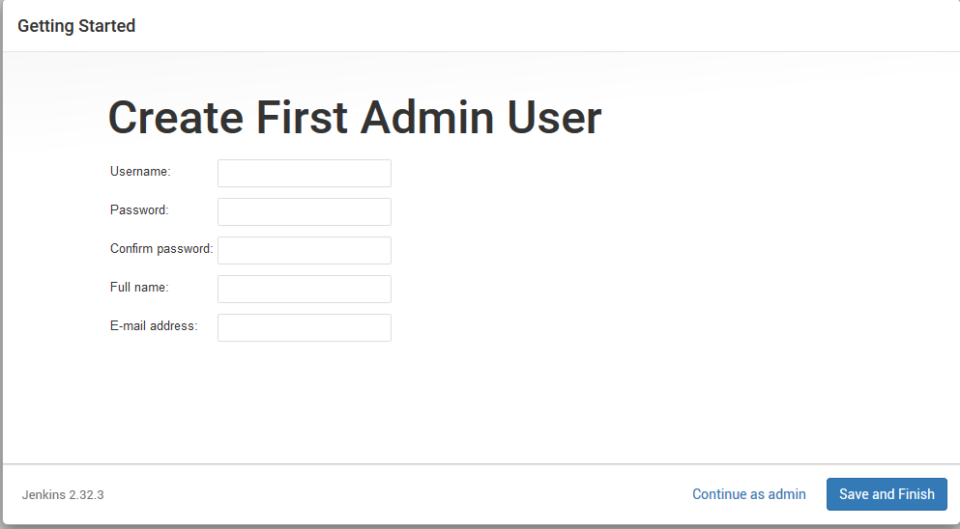

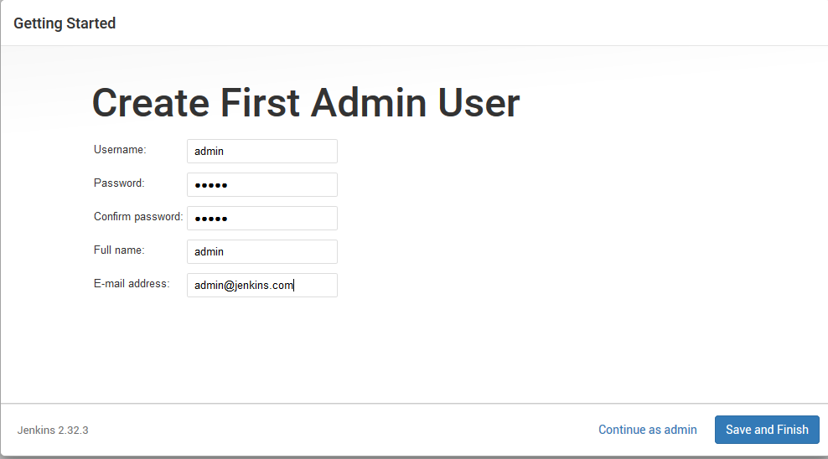

###### Save and Finish

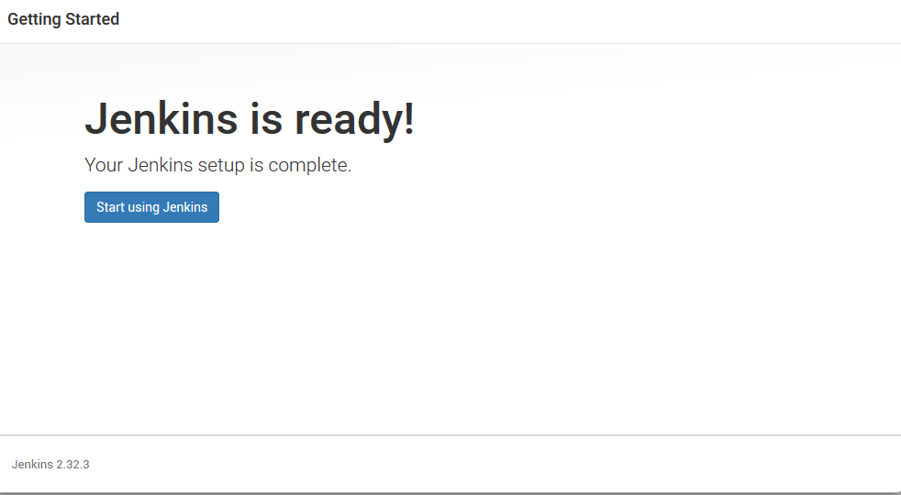

Login Jenkins UI

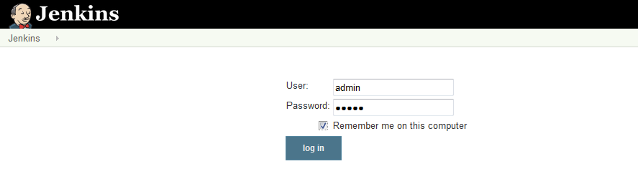

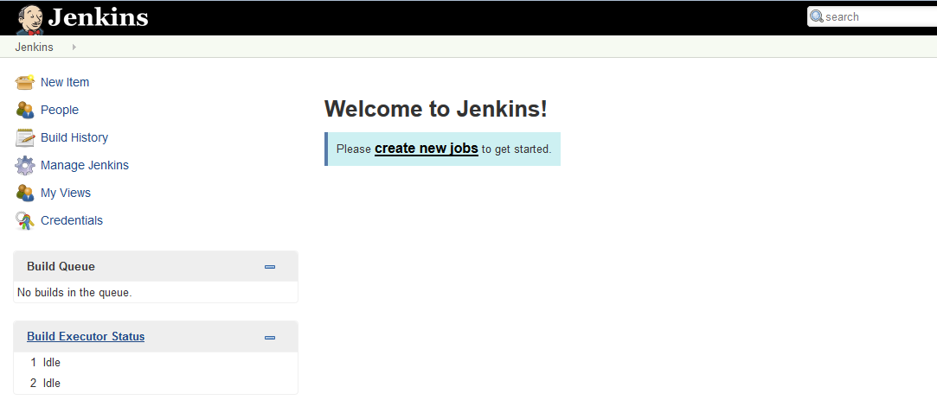

## install RF and Third library

### Install Robotframework

##### install RF

sudo apt-get install python-pip

sudo pip install --upgrade pip

sudo pip install robotframework

##### install RF library

sudo apt-get install python-wxgtk*

sudo pip install robotframework-ride

sudo pip install --upgrade robotframework-httplibrary

sudo apt-get install build-essential libssl-dev libffi-dev python-dev

#此步骤如果不执行，会出现安装cryptography失败，具体错误参考“setup cryptography failed”章节的内容。

sudo pip install --upgrade robotframework-SSHLibrary

##### other package

sudo apt install sshpass

##### Problems encountered

###### setup cryptography failed

writing top-level names to src/cryptography.egg-info/top_level.txt

writing dependency_links to src/cryptography.egg-info/dependency_links.txt

writing entry points to src/cryptography.egg-info/entry_points.txt

reading manifest file 'src/cryptography.egg-info/SOURCES.txt'

reading manifest template 'MANIFEST.in'

no previously-included directories found matching 'docs/_build'

warning: no previously-included files matching '*' found under directory 'vectors'

writing manifest file 'src/cryptography.egg-info/SOURCES.txt'

running build_ext

generating cffi module 'build/temp.linux-x86_64-2.7/_padding.c'

creating build/temp.linux-x86_64-2.7

generating cffi module 'build/temp.linux-x86_64-2.7/_constant_time.c'

generating cffi module 'build/temp.linux-x86_64-2.7/_openssl.c'

building '_openssl' extension

creating build/temp.linux-x86_64-2.7/build

creating build/temp.linux-x86_64-2.7/build/temp.linux-x86_64-2.7

x86_64-linux-gnu-gcc -pthread -DNDEBUG -g -fwrapv -O2 -Wall -Wstrict-prototypes -fno-strict-aliasing -Wdate-time -D_FORTIFY_SOURCE=2 -g -fstack-protector-strong -Wformat -Werror=format-security -fPIC -I/usr/include/python2.7 -c build/temp.linux-x86_64-2.7/_openssl.c -o build/temp.linux-x86_64-2.7/build/temp.linux-x86_64-2.7/_openssl.o

build/temp.linux-x86_64-2.7/_openssl.c:434:30: fatal error: openssl/opensslv.h: No such file or directory

compilation terminated.

**error: command 'x86_64-linux-gnu-gcc' failed with exit status 1**

----------------------------------------

Command "/usr/bin/python -u -c "import setuptools, tokenize;__file__='/tmp/pip-build-CbMI0T/cryptography/setup.py';f=getattr(tokenize, 'open', open)(__file__);code=f.read().replace('\r\n', '\n');f.close();exec(compile(code, __file__, 'exec'))" install --record /tmp/pip-T5kRVj-record/install-record.txt --single-version-externally-managed --compile" failed with error code 1 in /tmp/pip-build-CbMI0T/cryptography/

Reference resources：

https://cryptography.io/en/latest/installation/#building-cryptography-on-linux

### Modify HttpLibrary code

##### Linux

vi /usr/local/lib/python2.7/dist-packages/HttpLibrary/__init__.py

Increase the following records, global cancelled certificate verification：

import ssl

ssl._create_default_https_context = ssl._create_unverified_context

##### Windows

Modify file of C:\Python27\Lib\site-packages\HttpLibrary\__init__.py, increase the following records, global cancelled certificate verification：

import ssl

ssl._create_default_https_context = ssl._create_unverified_context

## Running RF test cases

### Case execution condition

1. 3 nodes cluster, each node of disk space is greater than 8G

2. Each node disk/vdisk numbers shall not be less than 4 (> = 4)

instructions:

This part of the inspection is in test case of rf-automation\testcase\01_Create_Cluster\Prepare Cluster.robot\01_ENV_Check

### Problems encountered

###### 1.SSL certificate verify failed

When running RF test case, occur SSLcertificate verify failed issue:

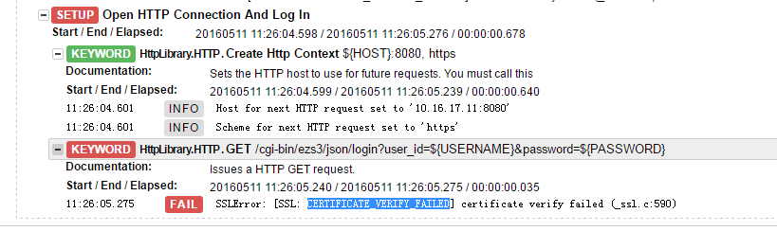

The solution：

Refer to the "Modify HttpLibrary code" section. Here only capture the record, if don't modify this problem will appear.

###### 2.Wait Until Keyword Succeeds occur CannotSendRequest

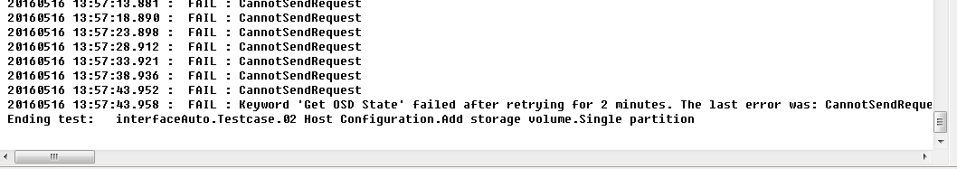

20160516 13:55:43.636 : INFO : ${osd_state} = OFFLINE

20160516 13:55:43.637 : INFO :

Argument types are:

<type 'str'>

<type 'unicode'>

20160516 13:55:43.637 : FAIL : OFFLINE != ONLINE

20160516 13:55:48.649 : FAIL : BadStatusLine: ''

20160516 13:55:53.656 : FAIL : CannotSendRequest

20160516 13:55:58.674 : FAIL : CannotSendRequest

20160516 13:56:03.679 : FAIL : CannotSendRequest

20160516 13:56:08.685 : FAIL : CannotSendRequest

20160516 13:56:13.695 : FAIL : CannotSendRequest

20160516 13:56:18.704 : FAIL : CannotSendRequest

20160516 13:56:23.718 : FAIL : CannotSendRequest

20160516 13:56:28.726 : FAIL : CannotSendRequest

20160516 13:56:33.742 : FAIL : CannotSendRequest

20160516 13:56:38.762 : FAIL : CannotSendRequest

20160516 13:56:43.780 : FAIL : CannotSendRequest

20160516 13:56:48.799 : FAIL : CannotSendRequest

20160516 13:56:53.817 : FAIL : CannotSendRequest

20160516 13:56:58.836 : FAIL : CannotSendRequest

20160516 13:57:03.852 : FAIL : CannotSendRequest

20160516 13:57:08.867 : FAIL : CannotSendRequest

20160516 13:57:13.881 : FAIL : CannotSendRequest

20160516 13:57:18.890 : FAIL : CannotSendRequest

20160516 13:57:23.898 : FAIL : CannotSendRequest

20160516 13:57:28.912 : FAIL : CannotSendRequest

20160516 13:57:33.921 : FAIL : CannotSendRequest

20160516 13:57:38.936 : FAIL : CannotSendRequest

20160516 13:57:43.952 : FAIL : CannotSendRequest

20160516 13:57:43.958 : FAIL : Keyword 'Get OSD State' failed after retrying for 2 minutes. The last error was: CannotSendRequest

Ending test: interfaceAuto.Testcase.02 Host Configuration.Add storage volume.Single partition

The solution：

root@host1:/# vi /etc/apache2/apache2.conf

modify

KeepAliveTimeout 5

to

KeepAliveTimeout 100

Units are seconds, then restart apache2 service。

instructions：

This is united into the robot file of rf-automation\testcase\01_Create_Cluster\Prepare Cluster.robot. If still appear, please check whether the apache conf was successfully modified, or to check the test case in file of Prepare Cluster.robot execute success or not.

## Create Jenkins Porject

### Enter an item name

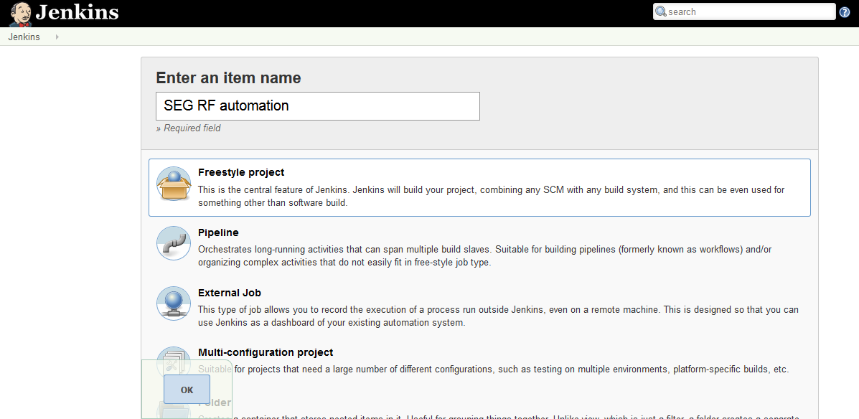

Click "OK"

### Source Code Management

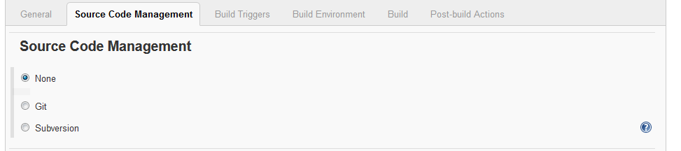

### Build Triggers

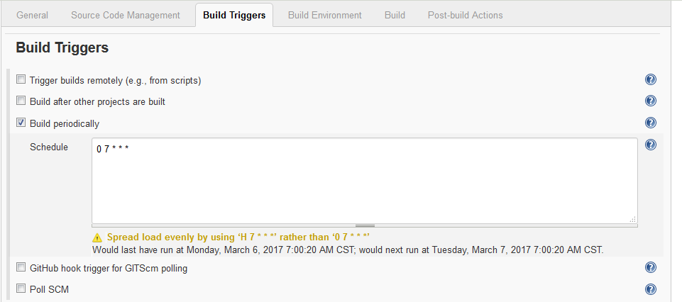

### Build Environment

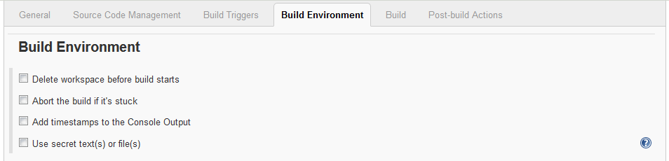

### Build

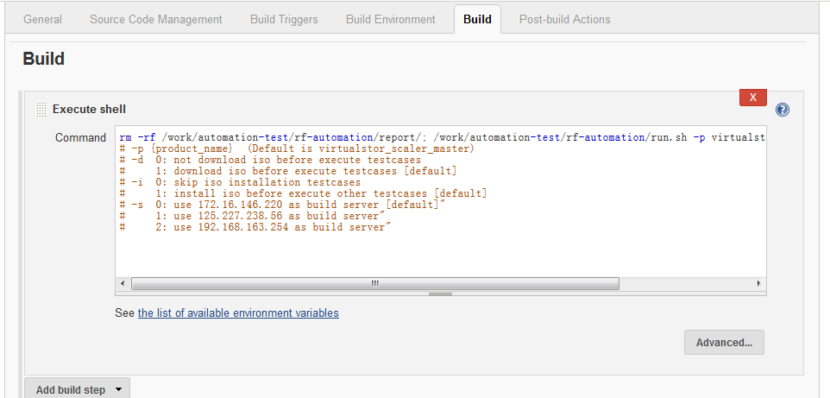

set properties file path to get ISO_NAME and RF running times. Before setting, should install this plug, search keyword is "inject".

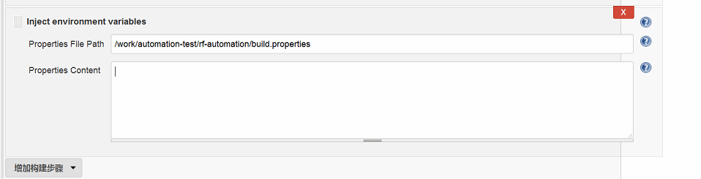

### Post-build Actions

###### Install robot framework plug

install robot framework plug to get total test cases/success test cases/failed test cases/ignore test cases and so on.

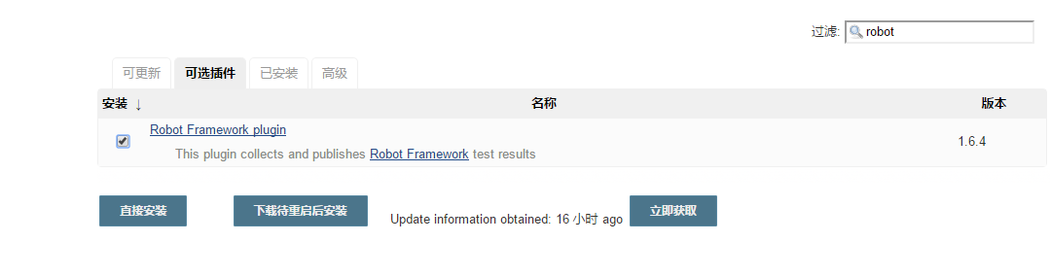

###### Editable Email Notification

Input follow content in "Default Content":

<html>

<head>

<title></title>

</head>

<body>

Hi All, <br>

This is the SEG Robot Framework Interface Automation Test Results. <br>

<font color="#0B610B" size="3"> Please click on the red link, check the console output, and check the continuous integration build results:</font> <a href="${BUILD_URL}console"><b><font color="#DF0101" size="3"> ${ENV, var="JOB_NAME"}</font></b></a>

<table width="95%" cellpadding="0" cellspacing="0" style="font-size:11pt; font-family:Tahoma, Arial, Helvetica, sans-serif">

<tr>

<td>

<h2>

<font color="#0000FF" size="4">Result: Passing rate - ${TEST_COUNTS,var="PASS"}&#47;${TEST_COUNTS}</font>

</h2>

</td>

</tr>

<tr>

<td>

<br>

<b><font color="#0B610B">Build information:</font></b>

<hr size="2" width="100%" align="center">

</td>

</tr>

<tr>

<td>

<ul>

<li>Project Name -- ${PROJECT_NAME}</li>

<li>Run ISO Version -- ${ISO_NAME} </li>

<li>RF Start/End Time -- From ${START_TIME} To ${END_TIME}</li>

<li>Build Serial Number -- The ${BUILD_NUMBER} times build</li>

<li>Trigger Reason -- ${CAUSE}</li>

<li>Build Result -- <a href="${PROJECT_URL}${BUILD_NUMBER}/robot/">${PROJECT_URL}${BUILD_NUMBER}/robot/</a> </li>

<li>Project URL -- <a href="${PROJECT_URL}">${PROJECT_URL}</a></li>

<li>Build URL -- <a href="${BUILD_URL}">${BUILD_URL}</a></li>

<li>Total cases -- $TEST_COUNTS</li>

<li>Pass cases -- ${TEST_COUNTS,var="pass"}</li>

<li>Fail cases -- ${TEST_COUNTS,var="fail"}</li>

<li>Skip cases -- ${TEST_COUNTS,var="skip"}</li>

<li>Git Version -- ${GIT_REVISION,length=8} </li>

</ul>

</td>

</tr>

<tr>

<td>

<b><font color="#0B610B">Since the last success build of the change</font></b>

<hr size="2" width="100%" align="center">

</td>

</tr>

<tr>

<td>

<ul>

<li>In this view the historical change: -- <a href="${PROJECT_URL}changes">${PROJECT_URL}changes</a>

</li>

</ul>${CHANGES_SINCE_LAST_SUCCESS, reverse=true, format="Changes for Build #%n:<br>%c<br>", showPaths=true, changesFormat="<pre>[%a]<br>%m</pre>", pathFormat="&nbsp;&nbsp;&nbsp;&nbsp;%p"}

</td>

</tr>

<tr>

<td>

<br>

</td>

</tr>

<tr>

<td>

<b><font color="#0B610B">Failure of the test results:</font></b>

<hr size="2" width="100%" align="center">

</td>

</tr>

<tr>

<td>

<pre style="font-size:11pt; font-family:Tahoma, Arial, Helvetica, sans-serif">

$FAILED_TESTS

</pre><br>

</td>

</tr>

<tr>

<td>

<b><font color="#0B610B">Build log (The last 100 rows record):</font></b>

<hr size="2" width="100%" align="center">

</td>

</tr>

<tr>

<td>

The test log (if run the test): <a href="${PROJECT_URL}${BUILD_NUMBER}/console">${PROJECT_URL}${BUILD_NUMBER}/console</a><br>

<br>

</td>

</tr>

</table>

<hr size="2" width="100%" align="center" />

(Note: This E-mail generated by system automatically, please do not reply!)

<tr> <td>

<br>

</td>

</tr>

</body>

</html>

###### Add publish robot framework test results

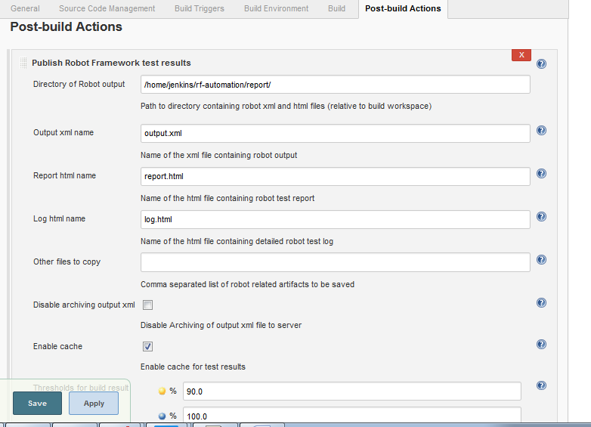

Then, save it.

### Jenkins System Config

###### Config System

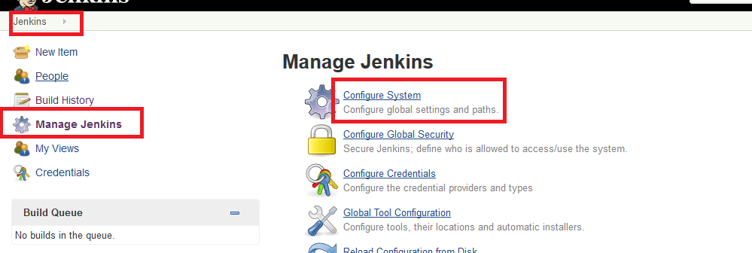

###### Set System Admin e-mail address

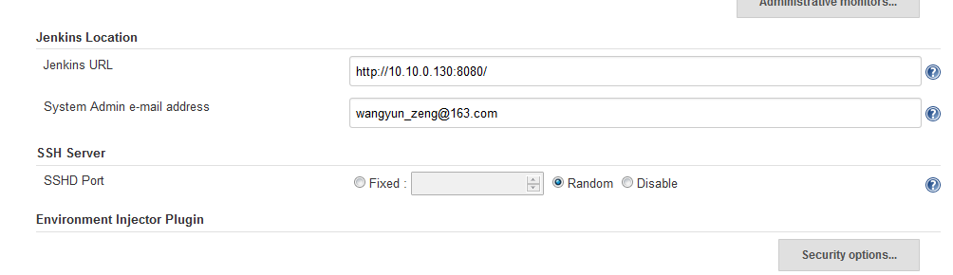

###### Extended E-mail Notification

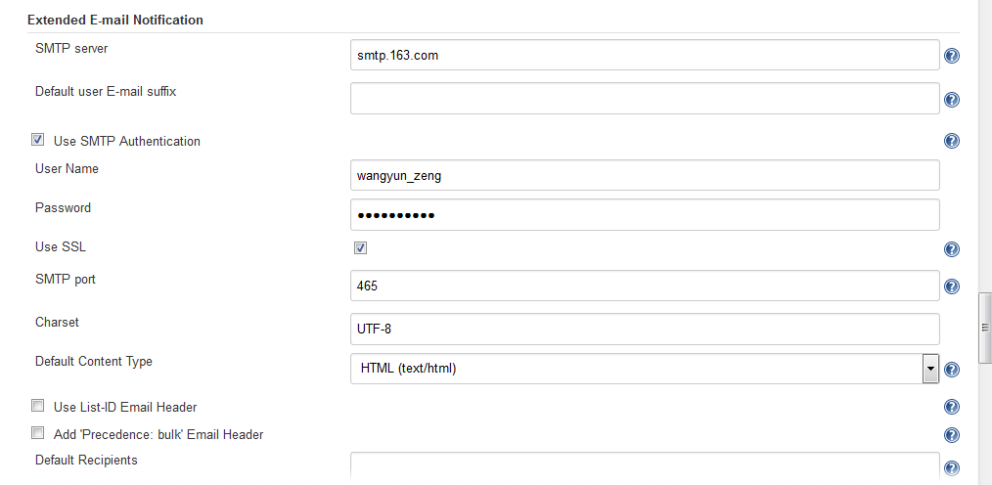

###### E-mail Notification

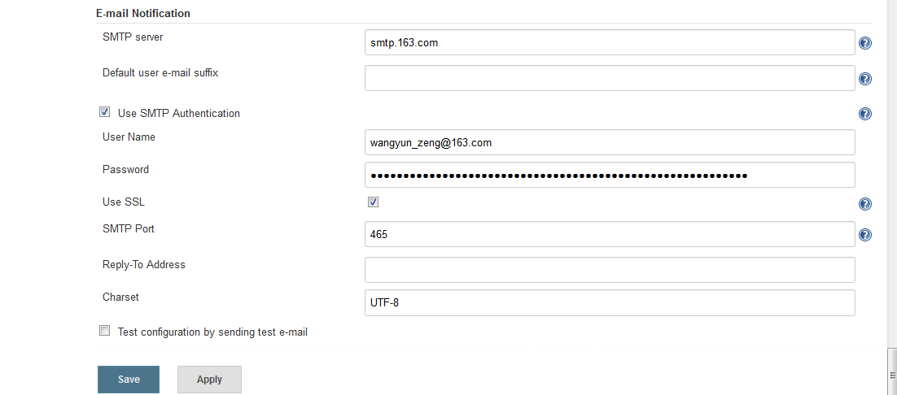

project的详细配置，请参考Nanking lab 172.16.146.234的设置。

### E-mail Over View

The below is the received email, e.g:

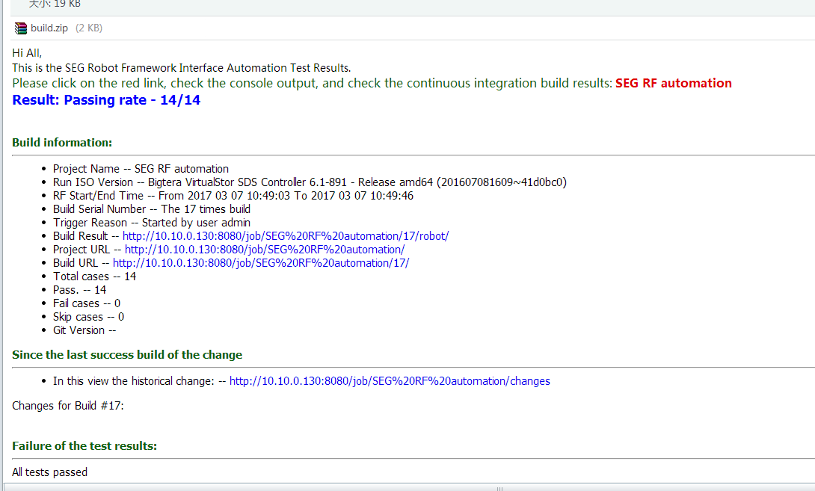

That's all.